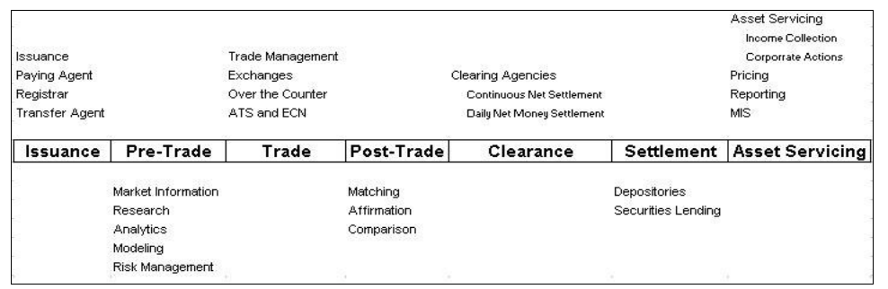

**Pre-Trade** **Trade** **Post-Trade**

**Trade life cycle.**

1. **Issuance**: The life cycle starts with the creation of an instrument through a process called issuance .i.e. Initial Public Offering (IPO). Other securities like Government securities may be issued through auctions. Once a security is issued, if it meant to be publicly traded, it is usually listed on one or more exchanges.

2. **Pre-Trade**: The security is available for trading in the secondary market after it is issued. Investors examine the security in the pre-trade phase. They gather information, conduct research, and perform analytics or modelling to evaluate the overall risk of their portfolio and the impact of the trade under consideration. All the activities before a buy side firm or an investor reaches a decision to place an order to buy or sell a particular security is typically classified as Pre-trade activities.

3. **Trade**: To buy or sell a security the investor has to find a counter party. This happens in the trading phase. Trading may be facilitated by an exchange or electronic communication network where the security is listed. In case of certain securities, trading may happen Over The Counter. In this case the securities are not listed and most of the trading happens over the telephone or through computer networks that directly connects dealers.

4. **Post-Trade**: After the trade is made, both the counter parties need to confirm that the trade they made was identical to the one the counter party thought was accomplished. The process of Matching and Confirming/Affirming the trades is usually facilitated by the Exchange and the Clearing House associated with the exchange.

5. **Clearing**: The procedure by which a clearing organization acts as an intermediary and assumes the role of a buyer and seller for transactions in order to reconcile orders between transacting parties. It involves deciding the amounts of cash and securities that trade participants would receive or deliver. This process requires a huge infrastructure and connectivity between all the participants and is supported by Clearing Agencies.

6. **Settlement**: This is the process of final exchange of securities for cash and is usually facilitated by the depository and clearing banks of the broker dealers.

7. **Asset Servicing**: This includes all activities conducted by the issuer as well as the investor after the security is delivered to the investor. Examples of such activities are preparing reports and statements, processing corporate actions such as dividend distribution and stock splits, securities lending, collateral management etc.

**Trading**

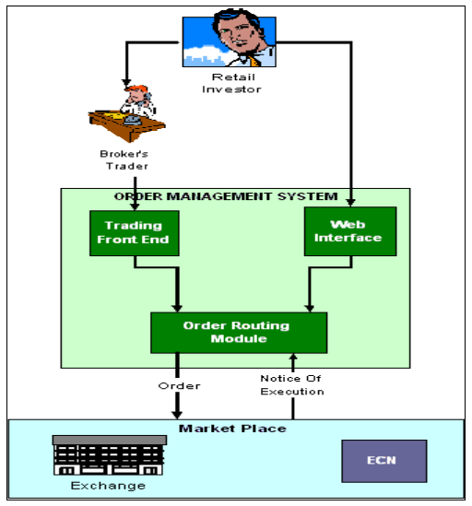

• As shown in the diagram above, trades are either initiated by the customer calling his or her broker or, increasingly, by using the electronic forms of order entry such as the internet.

• In case the investor is transacting through a trader (broker’s representative), the trader would place the order on behalf of the investor using the order management system available.

• Depending on the type of OMS available, the trader might be able to route the order to a specific exchange or an ECN network. In doing so, depending on the order type and size, the trader may combine the order with other orders or even split it. If the security is not listed on the exchange the trader may perform an over the counter deal through another broker/dealer. The OMS is responsible for the connectivity to various exchanges and ECN. Once the order is placed with the exchange, it remains in the exchange’s order book till the time a matching order of the opposite side is available. Once the orders and matched, it results in a trade and the trader/investor received a notice of execution (NOE) indicating the quantity and price at which the trade was executed.

**Post-Trade Processing**:

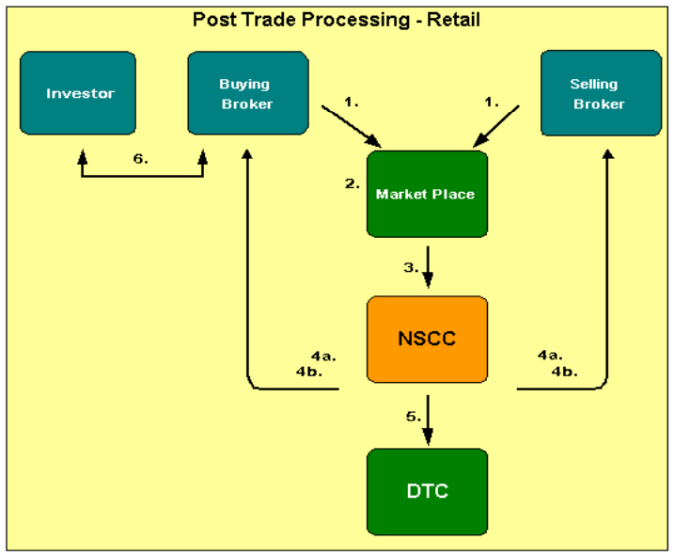

The above diagram represents the post-trade processing that happens in case of a investor.

1. Since, investors have to always buy or sell through a broker; the Buy and sell orders are routed by the buying/selling broker respectively to the marketplace.

2. Depending on the price, time and quantity the orders are matched and the trade gets executed at the exchange.

3. Trade Date T: Details of the trade are then sent to NSCC (**National Securities Clearing Corporation**, *Note: The capital market regulator SEBI has said that* ***Indian Clearing Corporation Ltd (ICCL)*** *are the only qualified central counterparties in the Indian securities market.*) for further processing. The trade details have all necessary information regarding the trade; i.e. the trade date, the quantity and price it was executed, the buying broker’s ID and the selling broker’s ID etc.

With most bond trades (and some stock trades), each broker-dealer submits its side of the trade to NSCC, and NSCC compares both sides to see that all details match. This happens on the trade date “T” itself.

4. On T+1:

- On “T+1”, NSCC issues to participating firms computerized reports known as "T contracts." These contracts, the legally binding documents for a trade, show the details of all locked-in trades. These documents confirm that the transactions have compared and are ready for settlement in the Continuous Net Settlement (CNS) system. NSCC's guarantee of settlement begins after midnight of T+1 when it reports back to its customers that the trades have been compared.

- Since, it is possible that a single broker may have multiple trades on both buy and sell side for the same security (executed for different customers); this could lead to a prohibitively large number of transactions that might have to be settled. Hence NSCC performs a process called “Netting” for each security to determine the net obligation of each broker. I.e. at the end of the process it is know for each security, whether a particular broker has to deliver shares or receive money. Then NSCC issues to broker-dealers a summary of all compared trades, the net positions and the money settlement that will be required the following day, which is settlement day

5. Settlement Date T+2: On “T+2” which is the settlement day NSCC also nets the dollar amounts that broker-dealers will receive from or pay to NSCC to satisfy their trading obligations for the day. NSCC then issues money settlement instructions to each broker-dealer and its settling bank. Each broker-dealer member of NSCC is required to designate a bank that will handle money settlement for the trades. Based on these instructions, NSCC either wires the bank money, or has the bank wire NSCC money to settle the broker-dealer's obligations. NSCC and the banks use the Federal Reserve electronic wire (or Fed Wire) system to electronically transfer funds the same day. Since all money obligations are netted, a single wire transfer can settle all the obligations for all securities handled by a broker-dealer through NSCC for an entire trading day. NSCC also maintains an account at DTC (**Depository Trust Company** - *In India, depositories are National Securities Depository Ltd (NSDL) and Central Securities Depository Ltd (CDSL)*) through which it can issue instructions for book-entry transfer of securities to or from customers' accounts, depending on whether they owe or are owed these securities.